A Project Report
on
Charity Donation Management System

Submitted in partial fulfillment of requirements for the award of the course
of
EGB1221-DATABASE MANAGEMENT SYSTEMS
Under the guidance of

Dr. T.L. KAYATHRI

Assistant Professor / ECE

Submitted By
REVANTH BALAJI S R (927623BEC173)
RITHIK SURIYA M (927623BEC174)

DEPARTMENT OF ELECTRONICS AND COMMUNICATION
ENGINEERING

M.KUMARASAMY COLLEGE OF ENGINEERING
(Autonomous)
KARUR – 639 113
JUNE 2025

M. KUMARASAMY COLLEGE OF ENGINEERING
(Autonomous Institution affiliated to Anna University, Chennai)

KARUR – 639 113

BONAFIDE CERTIFICATE

This is to certify that this project report on “CHARITY DONATION MANAGEMENT SYSTEM” is the bonafide work of RITHIK SURIYA M (927623BEC174), REVANTH BALAJI S R (927623BEC173) who carried out the project work during the academic year 2024 – 2025 (EVEN) under my supervision.

Signature | Signature
Dr. T.L. KAYATHRI M.E.,Ph.D., | Dr. A. KAVITHA M.E.,Ph.D.,
SUPERVISOR, | HEAD OF THE DEPARTMENT,
Department of Electronics and Communication Engineering, | Department of Electronics and Communication Engineering,
M.Kumarasamy College of Engineering, | M.Kumarasamy College of Engineering,
Thalavapalayam, Karur -639 113. | Thalavapalayam, Karur -639 113.

ii

DEPARTMENT OF ELECTRONICS AND COMMUNICATION ENGINEERING
VISION OF THE INSTITUTION
To emerge as a leader among the top institutions in the field of technical education
MISSION OF THE INSTITUTION
- Produce smart technocrats with empirical knowledge who can surmount the global challenges
- Create a diverse, fully-engaged, learner-centric campus environment to provide quality education to the students
- Maintain mutually beneficial partnerships with our alumni, industry, and Professional associations

DEPARTMENT VISION, MISSION, PEO, PO AND PSO
Vision
To empower the Electronics and Communication Engineering students with emerging technologies, professionalism, innovative research and social responsibility.
Mission
M1: Attain the academic excellence through innovative teaching learning process, research areas & laboratories and Consultancy projects.
M2: Inculcate the students in problem solving and lifelong learning ability.
M3: Provide entrepreneurial skills and leadership qualities.
M4: Render the technical knowledge and skills of faculty members.

iii

PROGRAM EDUCATIONAL OBJECTIVES (PEOs)
- PEO1: Graduates will have successful Career in software industries and R&D divisions through continuous learning
- PEO2: Graduates will provide effective solutions for real world problems in the key domain of computer science and engineering and engage in lifelong learning.
- PEO3: Graduates will excel in their profession by being ethically and socially responsible
PROGRAM OUTCOMES (POs)
Engineering students will be able to:
- Engineering knowledge: Apply the knowledge of mathematics, science, engineering fundamentals, and an engineering specialization to the solution of complex engineering problems.
- Problem analysis: Identify, formulate, review research literature, and analyze complex engineering problems reaching substantiated conclusions using first principles of mathematics, natural sciences, and engineering sciences.
- Design/development of solutions: Design solutions for complex engineering problems and design system components or processes that meet the specified needs with appropriate consideration for the public health and safety, and the cultural, societal, and environmental considerations.
- Conduct investigations of complex problems: Use research-based knowledge and research methods including design of experiments, analysis and interpretation of data, and synthesis of the information to provide valid conclusions.
- Modern tool usage: Create, select, and apply appropriate techniques, resources, and modern engineering and IT tools including prediction and modeling to complex engineering activities with an understanding of the limitations.
- The engineer and society: Apply reasoning informed by the contextual knowledge to assess societal, health, safety, legal and cultural issues and the consequent responsibilities relevant to the professional engineering practice.
iv

- Environment and sustainability: Understand the impact of the professional engineering solutions in societal and environmental contexts, and demonstrate the knowledge of, and need for sustainable development.
- Ethics: Apply ethical principles and commit to professional ethics and responsibilities and norms of the engineering practice.
- Individual and team work: Function effectively as an individual, and as a member or leader in diverse teams, and in multidisciplinary settings.
- Communication: Communicate effectively on complex engineering activities with the engineering community and with society at large, such as, being able to comprehend and write effective reports and design documentation, make effective presentations, give and receive clear instructions.
11. Project management and finance: Demonstrate knowledge and understanding of the engineering and management principles and apply these to one’s own work, as a member and leader in a team, to manage projects and in multidisciplinary environments.
12. Life-long learning: Recognize the need for, and have the preparation and ability to engage
in independent and life-long learning in the broadest context of technological change.

PROGRAM SPECIFIC OUTCOMES (PSOs)
- PSO1: Professional Skills: Ability to apply the knowledge of computing techniques to design and develop computerized solutions for the problems.
- PSO2: Successful career: Ability to utilize the computing skills and ethical values in creating a successful career.

v

ACKNOWLEDGEMENT

We gratefully remember our beloved Founder Chairman, (Late) Thiru. M. Kumarasamy, whose vision and legacy laid the foundation for our education and inspired us to successfully complete this project.
We extend our sincere thanks to Dr. K. Ramakrishnan, Chairman, and Mr. K. R. Charun Kumar, Joint Secretary, for providing excellent infrastructure and continuous support throughout our academic journey.
We are privileged to extend our heartfelt thanks to our respected Principal, Dr. B. S. Murugan, B.Tech., M.Tech., Ph.D., for providing us with a conducive environment and constant encouragement to pursue this project work.
We sincerely thank Dr. A. Kavitha, B.E., M.E., Ph.D., Professor and Head, Department of Electronics and Communication Engineering, for her continuous support, valuable guidance, and motivation throughout the course of this project.
Our special thanks and deep sense of appreciation go to our Project Supervisor, Dr.T.L.KAYATHRI.,M.E.,Ph.D.,Assistant Professor, Department of Electronics and Communication Engineering, for his exceptional guidance, continuous supervision, constructive suggestions, and unwavering support, all of which have been instrumental in the successful execution of this project.
We would also like to acknowledge Mrs.M.Sentamilselvi, B.E.,M.E., Assistant Professor, our Class Advisor for their constant encouragement and coordination that contributed to the smooth progress and completion of our project work.
We gratefully thank all the faculty members of the Department of Electronics and Communication Engineering for their timely assistance, valuable insights, and constant support during various phases of the project.
Finally, we extend our profound gratitude to our parents and friends for their encouragement, moral support, and motivation, without which the successful completion of this project would not have been possible.

vi

ABSTRACT

This project presents a Charity Donation Management System developed using SQL to efficiently manage and organize donor, donation, campaign, and beneficiary data. By leveraging SQL, the system ensures accurate data storage, retrieval, and reporting, enhancing transparency and accountability in charitable operations. Core features include donor registration, donation tracking, and fund allocation, all managed within a relational database. The system supports generating detailed reports and performing queries to analyze fundraising performance and donor behavior. Automation of these processes reduces manual workload and improves overall efficiency. With a structured backend, the system is scalable and suitable for both small and large nonprofit organizations. It ultimately aims to build trust and improve the effectiveness of donation management through reliable data handling.

vii

ABSTRACT WITH POs AND PSOs MAPPING

ABSTRACT | COs MAPPED | POs MAPPED | PSOs MAPPED
This project presents a Charity Donation Management System developed using SQL to efficiently manage and organize donor, donation, campaign, and beneficiary data. By leveraging SQL, the system ensures accurate data storage, retrieval, and reporting, enhancing transparency and accountability in charitable operations. Core features include donor registration, donation tracking, and fund allocation, all managed within a relational database. The system supports generating detailed reports and performing queries to analyze fundraising performance and donor behavior. Automation of these processes reduces manual workload and improves overall efficiency. With a structured backend, the system is scalable and suitable for both small and large nonprofit organizations. It ultimately aims to build trust and improve the effectiveness of donation management through reliable data handling. | CO1  CO2  CO3  CO4  CO5 | PO1  PO2  PO3  PO4  PO5  PO6  PO7  PO8  PO9  PO10  PO11  PO12 | PSO1  PSO2
Note: 1- Low, 2-Medium, 3- High

SUPERVISOR HEAD OF THE DEPARTMENT

viii

TABLE OF CONTENTS
CHAPTER  No. | TITLE | PAGE  No.
 | ABSTRACT | viii
1 | INTRODUCTION | 1
 | 1.1 OBJECTIVE | 1
 | 1.2 OVERVIEW | 1
 | 1.3 DATABASE MANAGEMENT SYSTEMS’ CONCEPTS | 2
2 | PROJECT METHODOLOGY | 3
 | 2.1 PROPOSED WORK | 3
 | 2.2 ARCHITECTURE | 4
 | 2.3 E-R DIAGRAM | 5
3 | MODULE DESCRIPTION | 6
 | 3.1 DONOR MANAGEMENT MODULE | 6
 | 3.2 DONATION TRACKING MODULE | 6
 | 3.2.1 FUND ALLOCATION MODULE | 6
 | 3.3 EVENT MANAGEMENT MODULE | 7
 | 3.4 REPORTING AND ANALYTICS MODULE | 7
4 | RESULTS AND DISCUSSION | 8
5 | CONCLUSION | 10
 | REFERENCES | 11
 | APPENDIX | 14

CHAPTER 1

INTRODUCTION

OBJECTIVE

The objective of the Charity Donation Management System is to provide a secure and user-friendly platform for managing online donations. It aims to simplify the donation process for users while ensuring transparency in how funds are collected and utilized. The system reduces manual work by automating tasks like donor tracking, receipt generation, and campaign monitoring. It enhances donor trust through real-time updates and access to donation history. Overall, the system helps charitable organizations operate more efficiently and make a greater social impact.

OVERVIEW

The Charity Donation Management System is a web-based application designed to streamline and digitize the donation process for nonprofit organizations and charitable institutions. It serves as a centralized platform where donors can easily contribute to various causes, and administrators can efficiently manage donation campaigns, donor records, and fund allocations. The system ensures transparency by allowing donors to track their contributions and receive real-time updates about how their funds are being used. It also supports secure payment processing, automated receipt generation, and detailed reporting to help organizations monitor campaign performance. Overall, the system enhances trust, reduces administrative burden, and promotes effective charitable giving through technology.

1

1.3 DATABASE MANAGEMENT SYSTEMS’ CONCEPTS
This section explains the important database concepts used in the project and how they help build an efficient and reliable system.

1.3.1 Tables and Relations

In a DBMS, data is organized into tables, also called relations. Each table contains rows (records)and columns (fields). In this project, we created separate tables for flights, flight details, passenger profiles, ticket info, and payment details. These tables are linked togetherusing keys to avoid repeating data and to make searching easier.

2

CHAPTER 2
PROJECT METHODOLOGY

2.1 PROPOSED WORK
- Design tables for Donor, Charity, and Donation.
- Link tables using foreign keys (DonorID and CharityID).
- Enforce data validation (e.g., valid email, positive donation amount).
- Create queries and reports for tracking donations and performance.
- Build a user-friendly interface for managing data. Implement security measures to protect sensitive information.

3

2.2 ARCHITECTURE

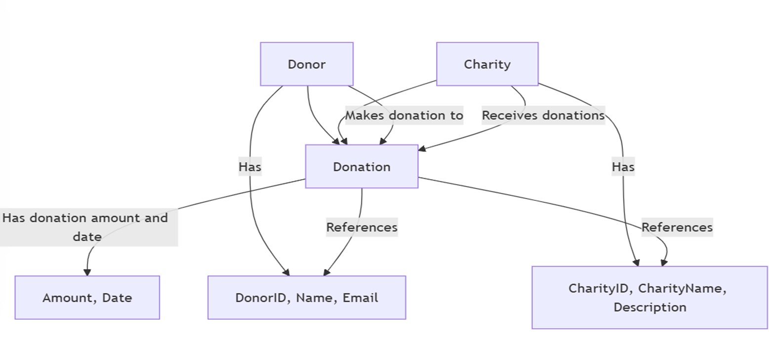

Fig 2.1 Charity Donation Management System

The diagram illustrates the architecture of a donation system, comprising three core entities: Donor, Charity, and Donation. The Donor entity holds details such as DonorID, Name, and Email, while the Charity entity includes CharityID, CharityName, and Description. The Donation entity serves as a central link between donors and charities, capturing information about each donation, including the amount and date. A donor makes a donation to a charity, and the charity receives it, establishing a many-to-many relationship managed through the Donation entity. This structure ensures that each donation can be clearly traced back to both the donor and the recipient charity, providing a well-organized and trackable system for managing donations.

4

2.3 E-R DIAGRAM
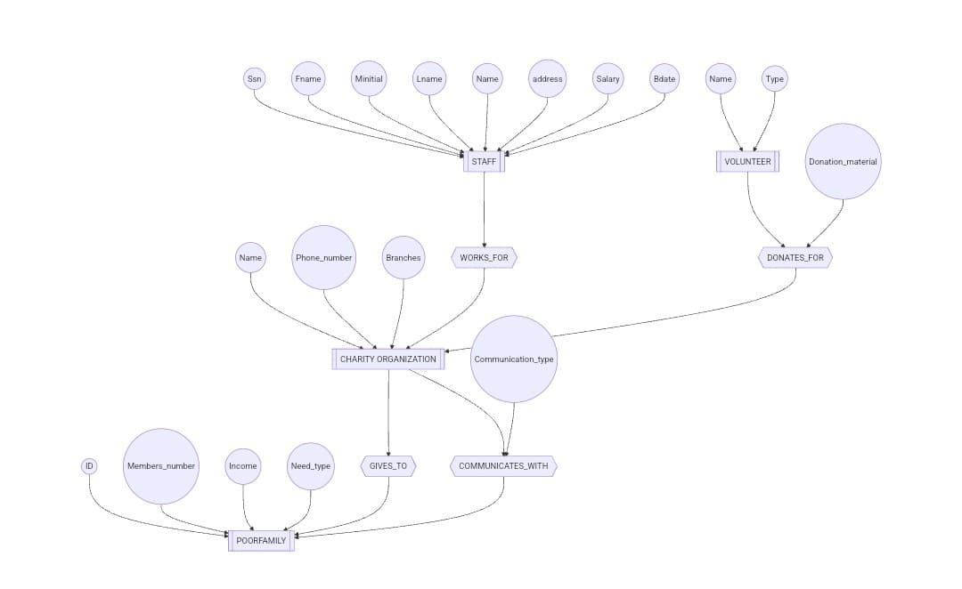

Fig 2.2 Charity Donation Management System

This er diagram represents the structure of a charity support system. At the center is the Charity Organization, which interacts with both Staff and Volunteers. Staff members, identified by details such as SSN, name, address, salary, and birthdate, work for the charity. Volunteers, identified by name and type, donate materials to the organization. The charity also serves Poor Families, which are described by attributes like ID, number of members, income, and type of need. The organization communicates with these families using a defined Communication_type, and provides support based on their needs. This system structure ensures organized management of internal staff, external volunteers, and the families they aim to help.

5

CHAPTER 3
MODULE DESCRIPTION

3.1 Donor Management Module

The Donor Management Module stores and organizes information about all individuals and organizations that contribute to the charity. It includes donor details such as name, contact information, and registration date. This module helps track donation history and build long-term donor relationships. Users can easily search, update, or remove donor records as needed. It ensures accurate and up-to-date donor data for communication and reporting.

3.2 Donation Tracking Module

This module records every donation made to the charity, capturing key details like donor ID, amount, donation type (cash, goods, online), and date. It maintains a complete log of all financial and non-financial contributions. Each donation is linked to a specific donor to ensure traceability. The module allows filtering donations by type, date, and status. It is essential for maintaining financial transparency and donor trust.

3.2.1 Fund Allocation Module

The Fund Allocation Module manages how collected donations are distributed across various charity projects. It records the amount allocated to each project along with the date and source of funds. This module ensures that resources are properly assigned and tracked. It supports auditing and accountability by maintaining clear records of every allocation. Reports generated from this module help assess fund usage efficiency.

6

3.3 Event Management Module

This module handles the planning and tracking of fundraising events organized by the charity. It stores event details such as name, location, date, and description. Donor participation in events and donations made during these events are recorded here. It helps the organization evaluate the effectiveness of events in raising funds. The module also links donors to events for better engagement and follow-up.

3.4 Reporting and Analytics Module

The Reporting and Analytics Module generates detailed insights into the charity’s operations. It provides reports on donor activity, donation trends, fund allocations, and event performance. Users can apply filters like date range, donor type, or donation method to customize reports. These insights support strategic planning and performance monitoring. The module is crucial for transparency, compliance, and making data-driven decisions.

7

CHAPTER 4
RESULTS AND DISCUSSION

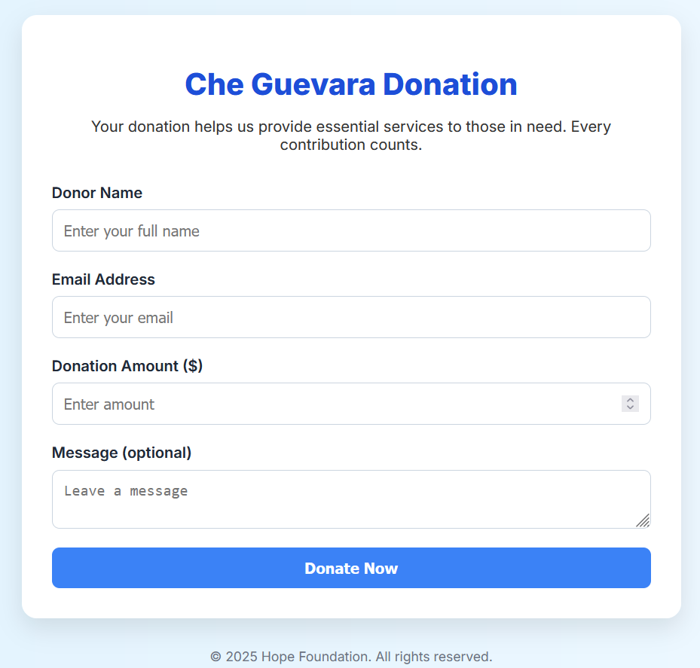

Fig 4.1 Enter the details of the Donar

This image displays a clean and user-friendly donation form for the "Che Guevara Donation" campaign, managed by the Hope Foundation. The purpose of the form is to collect essential donor information to facilitate charitable contributions. It includes fields for the Donor Name, Email Address, Donation Amount ($), and an optional Message. The form is designed with a clear call-to-action button labeled "Donate Now", encouraging users to submit their donations. At the bottom, it features a copyright notice for the year 2025, reinforcing the foundation's ownership and authenticity. The overall layout emphasizes ease of use, accessibility, and trustworthiness.

8
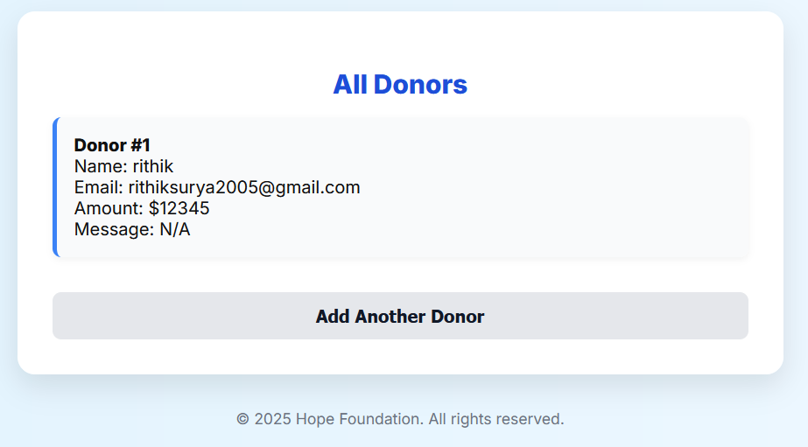

Fig 4.2 Store the details of the Donar

This image showcases a section of the donation system titled "All Donors", where individual donor contributions are displayed. It lists details for Donor #1, including the donor's name (rithik), email address, donation amount ($12345), and a message field, which in this case is marked as N/A (not applicable or not provided). The presentation is clear and minimalistic, making it easy to view donor details at a glance. Below the donor information, there is a prominent "Add Another Donor" button, allowing users to input additional contributions. This layout supports easy donor tracking while encouraging continuous engagement. The footer again references the 2025 Hope Foundation, reinforcing branding and ownership.

9

CHAPTER 5
CONCLUSION

This donation platform, Che Guevara Donation, was developed to simplify the donation process and foster a culture of giving. With a clean user interface, real-time donor display, and email integration via EmailJS, the application provides a smooth and impactful experience for both donors and administrators. It demonstrates how front-end technologies like HTML, CSS, and JavaScript can be used to build meaningful, socially driven applications. The project highlights not only technical skills but also the power of design in encouraging community support. This marks a step toward using technology for positive social change.

10

REFERENCES:

[1] Elmasri, R., & Navathe, S. B. (2016). Fundamentals of Database Systems. Pearson Education.This textbook is a foundational resource for understanding database design, ER modeling, normalization, and relational schemas.It provides a strong theoretical base for implementing a structured and efficient database for your project.The concepts outlined in this book help in building robust back-end data structures for a donation system.

[2] Silberschatz, A., Korth, H. F., & Sudarshan, S. (2019). Database System Concepts. McGraw-Hill.This book covers core DBMS topics such as transaction management, concurrency control, and indexing.It is especially useful for designing systems with secure and reliable transaction processing like donation entries.It also explains SQL in depth, which is crucial for querying and managing donor and charity data.

[3] Connolly, T., & Begg, C. (2015). Database Systems: A Practical Approach to Design, Implementation, and Management.This book offers practical examples and real-world case studies for designing and managing databases.It provides useful insights into how theoretical DBMS concepts are applied in working systems.It helps bridge the gap between academic design and practical implementation of donation systems.

[4] Ramakrishnan, R., & Gehrke, J. (2003). Database Management Systems. McGraw-Hill.
This reference is essential for understanding the internal workings of DBMS and optimization techniques.It supports the advanced querying and indexing required in a high-traffic donation management application.It also gives a deeper view into query evaluation and physical DB design.

[5] IEEE Xplore Digital Library – Articles on Online Charity Systems .A valuable source of peer-reviewed papers detailing real-world implementations of online donation systems.
You can study how other developers solve issues like scalability, security, and data integrity.These papers help justify the design decisions in your DBMS project report.
11

[6] MySQL 8.0 Reference Manual – Oracle Corporation.This is the official documentation for the MySQL database management system.It provides syntax, functions, data types, and performance tuning options specific to your DBMS.Essential for creating, querying, and maintaining the relational tables in your donation system.

[7] MDN Web Docs – Mozilla Developer Network.MDN offers authoritative documentation on HTML, CSS, and JavaScript.It is a crucial frontend resource for building the user interface of your donation form and donor lists.The site includes accessibility and mobile responsiveness best practices.

[8] W3Schools – Online Tutorials for Web and Backend Development.A widely-used platform to quickly learn SQL, PHP, JavaScript, and HTML.It provides step-by-step examples and exercises for connecting your web forms to the backend database.
Extremely helpful for building and testing the frontend/backend integration.

[9] GeeksforGeeks – Programming Tutorials and Concepts.This website offers tutorials on database systems, ER modeling, SQL queries, and backend development.It includes real-world coding problems and DBMS interview questions which reinforce learning.
Ideal for understanding query optimization, joins, and relational algebra concepts.

[10] GitHub – Open Source Donation and Charity System Repositories.GitHub hosts hundreds of project repositories that show real-world implementation of charity management systems.You can explore how projects handle user login, donations, data validations, and report generation.These repositories provide code examples and structural guidance for your own system.

[11] Draw.io (diagrams.net) – ERD and Schema Design Tool.A free tool used to create ER diagrams, flowcharts, and database schemas.It helps visually represent your system’s database structure for documentation and presentations.The diagrams made using this tool are often included in DBMS project reports.

12

[12] Lucidchart – Online Diagramming Tool.An alternative to Draw.io with professional templates for ER diagrams and UML models.It allows collaborative design, useful for team projects and academic submissions.Helps create clean and standardized models of your database schema.

[13] European Union – General Data Protection Regulation (GDPR).GDPR is crucial for understanding how to legally handle personal data such as donor names and emails.It mandates rules around data storage, consent, and privacy — all important in a charity system.Your system must comply with such regulations if deployed publicly.

[14] United Nations – Sustainable Development Goals (SDG), Goal 1 & Goal 17.These goals aim to eliminate poverty and promote partnerships, aligning directly with charity objectives.Citing the SDGs gives your project a meaningful real-world context and purpose.It helps justify the societal impact of your donation management system.

[15] Charity Navigator – Evaluation Platform for Nonprofit Organizations.Offers benchmarks for transparency, accountability, and efficiency in nonprofit operations.
Helps you design your system to include metrics that support public trust and data visibility.You can model your reporting features based on what donors expect from charity platforms.

13
APPENDIX
(Coding)

<!DOCTYPE html>
<html lang="en">
<head>
<meta charset="UTF-8" />
<meta name="viewport" content="width=device-width, initial-scale=1.0"/>
<title>Support Our Cause</title>
<link href="https://fonts.googleapis.com/css2?family=Inter:wght@400;600;800&display=swap" rel="stylesheet"/>
<script src="https://cdn.emailjs.com/dist/email.min.js"></script>
<script>
(function(){
emailjs.init("YOUR_PUBLIC_KEY"); // Replace with your actual public key
})();
</script>
<style>
* {
box-sizing: border-box;
}

body {
margin: 0;
font-family: 'Inter', sans-serif;
color: #111;
min-height: 100vh;
background: linear-gradient(to right, #e0f2fe, #f0f9ff);
display: flex;

14
flex-direction: column;
align-items: center;
justify-content: center;
padding: 2rem;
}

.slide {
display: none;
width: 100%;
max-width: 700px;
background-color: #ffffff;
padding: 2rem;
border-radius: 1rem;
box-shadow: 0 10px 25px rgba(0, 0, 0, 0.1);
}

.slide.active {
display: block;
}

h1, h2 {
text-align: center;
color: #1d4ed8; /* Blue title */
margin-bottom: 1rem;
}

p {
text-align: center;
margin-bottom: 2rem;
color: #333;
}

15
label {
font-weight: 600;
display: block;
margin-bottom: 0.5rem;
color: #1f2937;
}

input,
textarea {
width: 100%;
padding: 0.75rem;
border: 1px solid #cbd5e0;
border-radius: 8px;
margin-bottom: 1.25rem;
font-size: 1rem;
}

button {
width: 100%;
padding: 0.75rem;
background-color: #3b82f6;
color: white;
font-size: 1rem;
font-weight: 600;
border: none;
border-radius: 8px;
cursor: pointer;
transition: background-color 0.3s ease;
}

16
button:hover {
background-color: #2563eb;
}

ul {
list-style: none;
padding: 0;
margin: 0;
}

li {
background-color: #f9fafb;
border-left: 4px solid #3b82f6;
margin-bottom: 1rem;
padding: 1rem;
border-radius: 8px;
box-shadow: 0 2px 6px rgba(0, 0, 0, 0.05);
}

footer {
margin-top: 2rem;
font-size: 0.875rem;
color: #6b7280;
text-align: center;
}

form {
width: 100%;
}

17
back-btn {
background-color: #e5e7eb;
color: #111827;
margin-top: 1rem;
}

.back-btn:hover {
background-color: #d1d5db;
}
</style>
</head>
<body>

<div class="slide active" id="formSlide">
<h1>Che Guevara Donation</h1>
<p>Your donation helps us provide essential services to those in need. Every contribution counts.</p>
<form id="donationForm" onsubmit="sendEmail(event)">
<label for="name">Donor Name</label>
<input type="text" id="name" name="from_name" placeholder="Enter your full name" required />

<label for="email">Email Address</label>
<input type="email" id="email" name="to_email" placeholder="Enter your email" required />

<label for="amount">Donation Amount ($)</label>
<input type="number" id="amount" name="donation_amount" placeholder="Enter amount" required />

18
<label for="message">Message (optional)</label>
<textarea id="message" name="donor_message" placeholder="Leave a message"></textarea>

<button type="submit">Donate Now</button>
</form>
</div>

<div class="slide" id="detailsSlide">
<h2>All Donors</h2>
<ul id="donorList"></ul>
<button class="back-btn" onclick="goBack()">Add Another Donor</button>
</div>

<footer>
&copy; <span id="year"></span> Hope Foundation. All rights reserved.
</footer>

<script>
document.getElementById('year').textContent = new Date().getFullYear();

const donors = [];

function sendEmail(e) {
e.preventDefault();

const name = document.getElementById('name').value.trim();
const email = document.getElementById('email').value.trim();
const amount = parseFloat(document.getElementById('amount').value);
const message = document.getElementById('message').value.trim() || 'N/A';

19
if (!name || !email || amount <= 0) {
alert("Please fill all required fields with valid data.");
return;
}

const button = document.querySelector("button[type='submit']");
button.disabled = true;
button.textContent = "Sending...";

const templateParams = {
from_name: name,
to_email: email,
donation_amount: amount,
donor_message: message
};

emailjs.send('YOUR_SERVICE_ID', 'YOUR_TEMPLATE_ID', templateParams)
.then(function(response) {
alert("Thank you! A confirmation email has been sent.");
}, function(error) {
alert("Email failed to send. Please try again later.");
console.error("EmailJS Error:", error);
})
.finally(() => {
button.disabled = false;
button.textContent = "Donate Now";
});

donors.push({ name, email, amount, message });
updateDonorList();

20
document.getElementById('formSlide').classList.remove('active');
document.getElementById('detailsSlide').classList.add('active');

document.getElementById('donationForm').reset();
}

function updateDonorList() {
const donorList = document.getElementById('donorList');
donorList.innerHTML = '';
donors.forEach((donor, index) => {
const li = document.createElement('li');
li.innerHTML = `<strong>Donor #${index + 1}</strong><br>
Name: ${donor.name}<br>
Email: ${donor.email}<br>
Amount: $${donor.amount}<br>
Message: ${donor.message}`;
donorList.appendChild(li);
});
}

function goBack() {
document.getElementById('formSlide').classList.add('active');
document.getElementById('detailsSlide').classList.remove('active');
}
</script>

</body>
</html>

21

